**AJP ASSIGNMENT: 1**

1. **Create a List (try both Array List and LinkedList) and fill it using Collections2.countries. Sort the list and print it, then apply Collections. shuffle( ) to the list repeatedly, printing it each time so that you can see how the shuffle( ) method randomizes the list differently each time.**

**PROGRAM:**

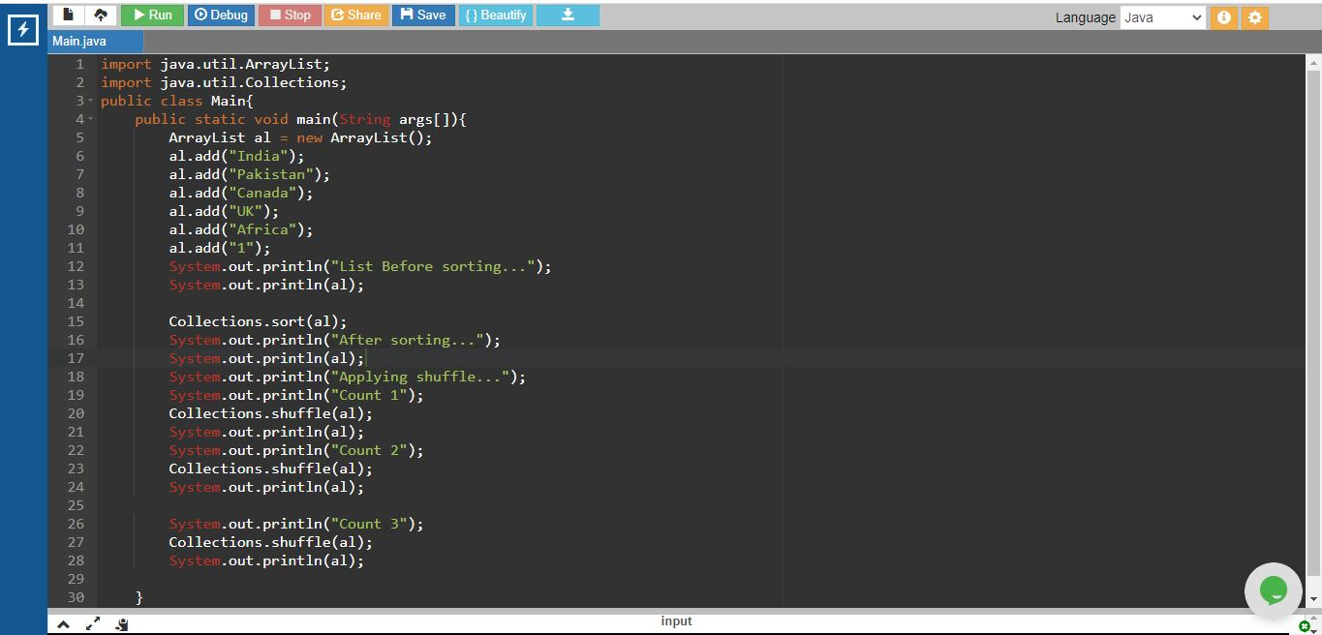

OUTPUT:

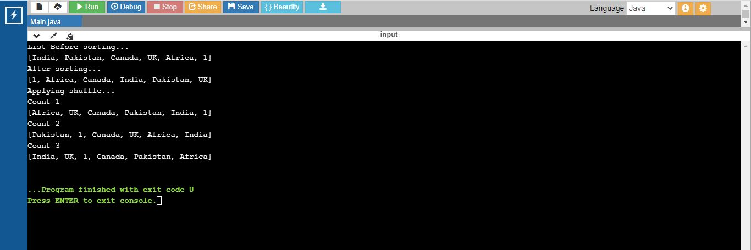

1. **Write a program which creates a concordance of characters occurring in a string (i.e., which characters occur where in a string). Read the string from the command line. Sample Output: >java Concordance Hello World {d=[9], o=[4, 6], r=[7], W=[5], H=[0], l=[2, 3, 8], e=[1]}**

**PROGRAM:**

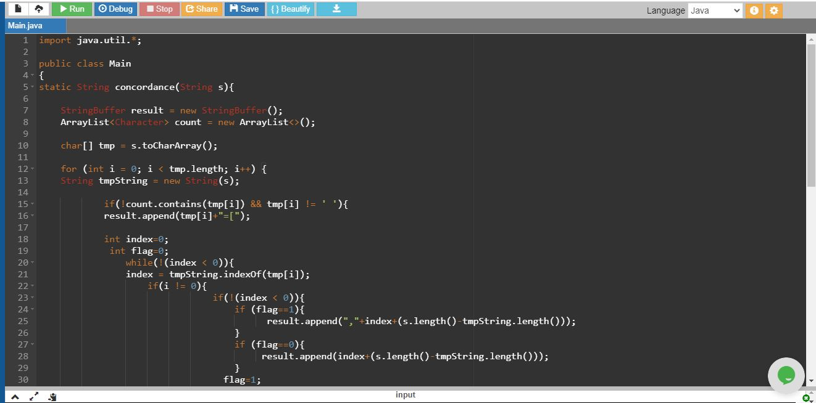

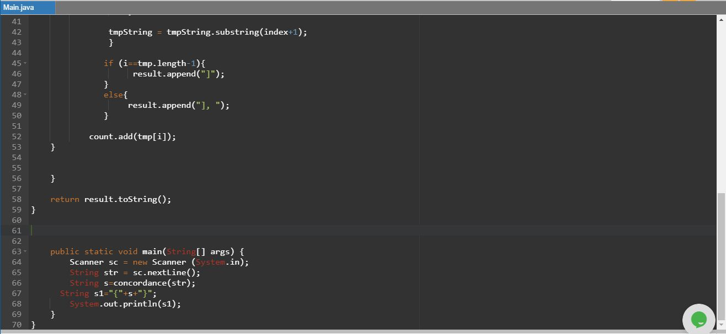

**OUTPUT:**

